Lesson 03 Demo 06

Managing Firewall and Network Access

Objective: To manage firewall and network access for storage accounts
Tools Required: Azure account

Prerequisites: Storage account

Steps to be followed:
- Manage firewall and network access

Step 1: Manage firewall and network access

- Navigate to the storage account that was previously created

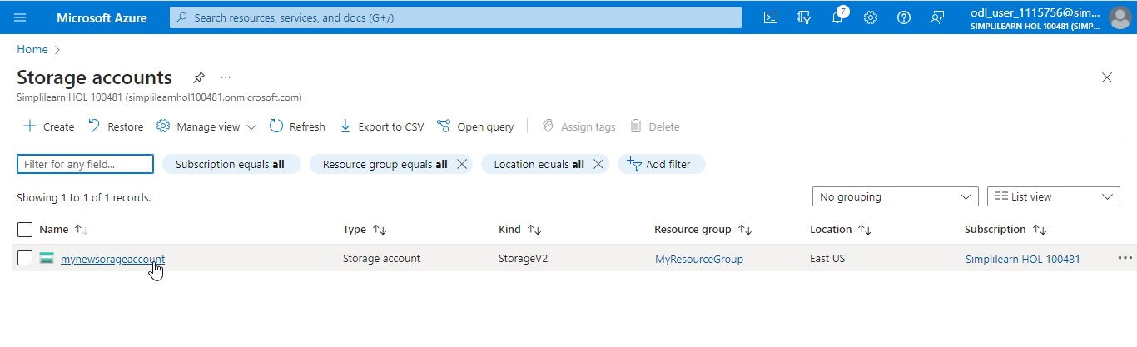

- Under Security + networking, locate the Networking

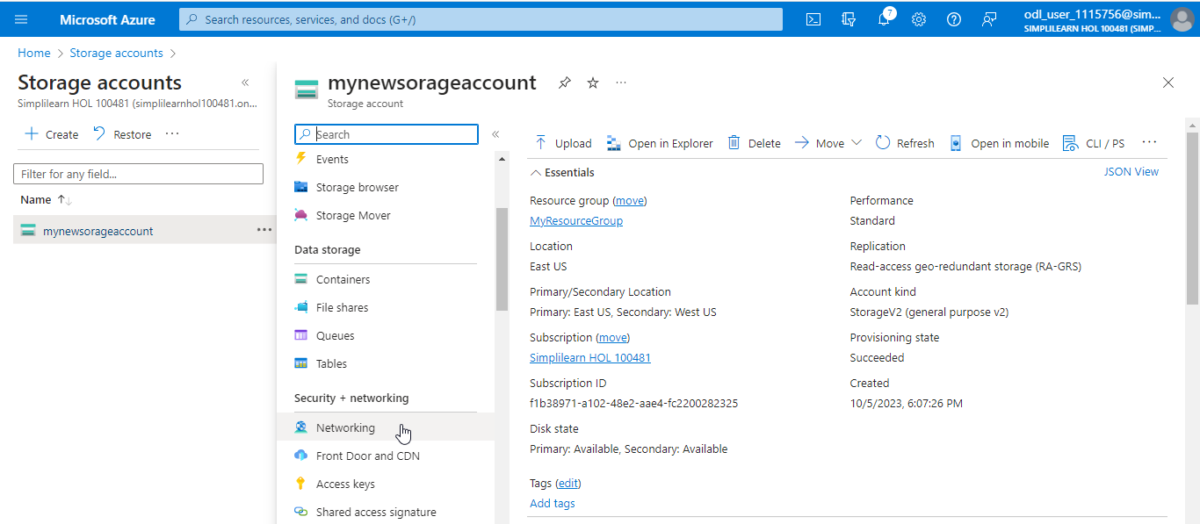

- In the Networking page, under Firewalls and virtual networks, select Enable from all networks and click on Save

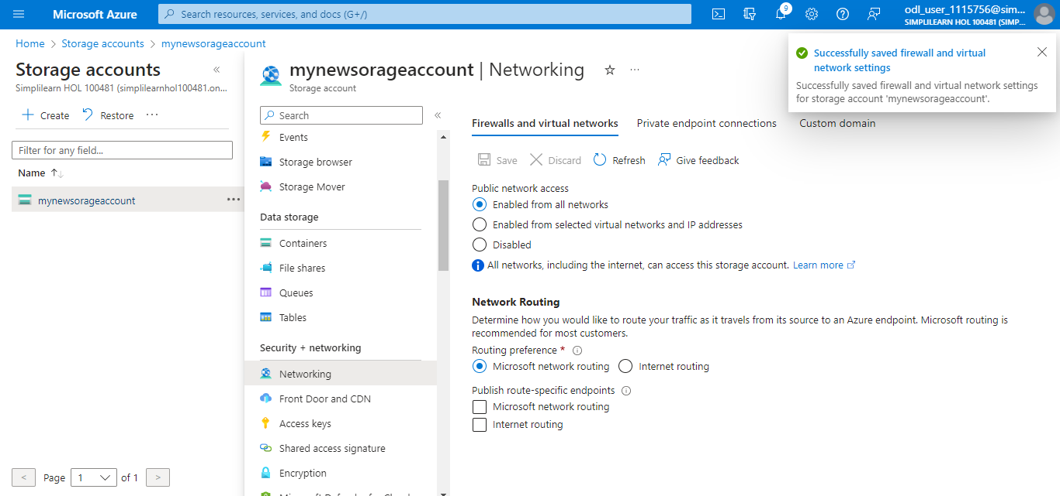

Note:
- To allow traffic from all networks, select Enabled for all networks
- To permit traffic only from specific virtual networks and IP addresses, choose Enabled from selected virtual networks and IP addresses. Then, select the desired Virtual Network and Subnet from the list.
- To block traffic from all networks, opt for Disabled. Upon selecting the Disabled option, public network access to this storage account will be turned off.

You have now successfully learned how to manage the firewall and network access for the storage account.

